Stock Market Analytics 📈
Analyze stocks, investors, portfolios, trades, and market performance using SQL to gain insights into trading behavior, portfolio performance, and investment trends.

🎯 Business Objectives
✅ Analyze stock trading activity
✅ Track investor portfolios
✅ Monitor stock price movements
✅ Measure portfolio performance
✅ Identify top-performing stocks
✅ Analyze trading volume
✅ Calculate investment returns
✅ Build executive investment dashboards

📂 Step 1: Create Database
CREATE DATABASE stock_market_db;
USE stock_market_db;
📂 Step 2: Create Investors Table
CREATE TABLE investors (
investor_id INT PRIMARY KEY,
investor_name VARCHAR(100),
city VARCHAR(50),
account_open_date DATE
📂 Step 3: Create Stocks Table
CREATE TABLE stocks (
stock_id INT PRIMARY KEY,
stock_symbol VARCHAR(20),
company_name VARCHAR(100),
sector VARCHAR(50)
);
📂 Step 4: Create Trades Table
CREATE TABLE trades (
trade_id INT PRIMARY KEY,
investor_id INT,
stock_id INT,
trade_date DATE,
transaction_type VARCHAR(10),
quantity INT,
price DECIMAL(10,2),
FOREIGN KEY (investor_id) REFERENCES investors(investor_id),
FOREIGN KEY (stock_id) REFERENCES stocks(stock_id)
);
📂 Step 5: Create Daily Prices Table
CREATE TABLE daily_prices (
price_id INT PRIMARY KEY,
stock_id INT,
price_date DATE,
open_price DECIMAL(10,2),
close_price DECIMAL(10,2),
high_price DECIMAL(10,2),
low_price DECIMAL(10,2),
volume BIGINT,
FOREIGN KEY (stock_id) REFERENCES stocks(stock_id)
);
📂 Step 6: Insert Sample Investors
INSERT INTO investors VALUES
(1,'Rahul Sharma','Mumbai','2023-01-15'),
(2,'Priya Verma','Delhi','2023-04-20'),
(3,'Amit Patel','Pune','2024-02-10'),
(4,'Sneha Joshi','Bangalore','2024-05-05'),
(5,'Rohan Gupta','Hyderabad','2024-07-18');
📂 Step 7: Insert Sample Stocks
INSERT INTO stocks VALUES
(101,'TCS','Tata Consultancy Services','IT'),
(102,'INFY','Infosys','IT'),
(103,'RELIANCE','Reliance Industries','Energy'),
(104,'HDFCBANK','HDFC Bank','Banking'),
(105,'TATAMOTORS','Tata Motors','Automobile');
📂 Step 8: Insert Sample Trades
INSERT INTO trades VALUES
(1001,1,101,'2025-01-05','BUY',10,4200),
(1002,2,102,'2025-01-06','BUY',20,1800),
(1003,3,103,'2025-01-07','SELL',5,2900),
(1004,4,104,'2025-01-08','BUY',15,1650),
(1005,5,105,'2025-01-09','BUY',25,980);
📂 Step 9: Insert Sample Daily Prices
INSERT INTO daily_prices VALUES
(1,101,'2025-01-05',4180,4215,4235,4170,1200000),
(2,102,'2025-01-06',1785,1810,1822,1778,980000),
(3,103,'2025-01-07',2880,2910,2925,2870,2100000),
(4,104,'2025-01-08',1640,1665,1672,1635,1750000),
(5,105,'2025-01-09',970,990,995,965,3100000);

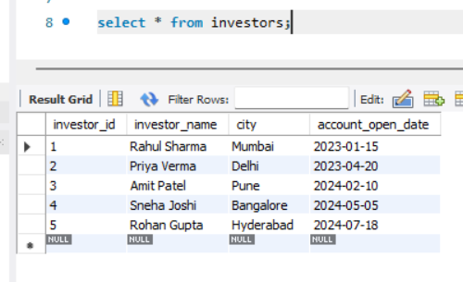

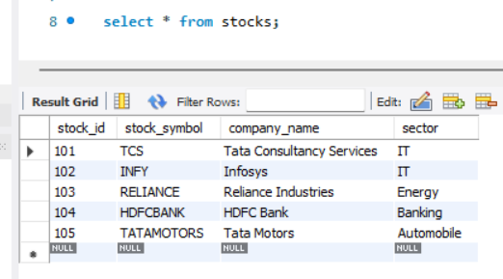

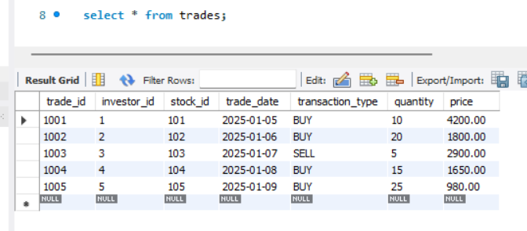

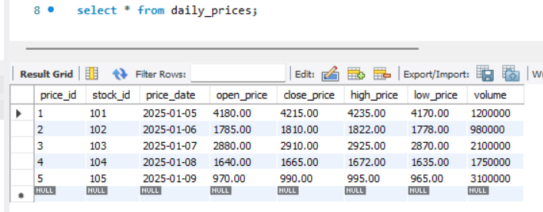

Business KPIs
📈 Total Investors
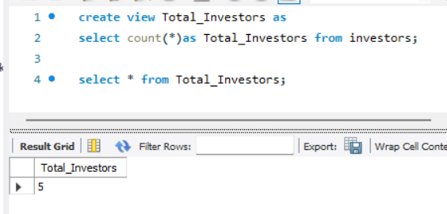
📈 Total Trades
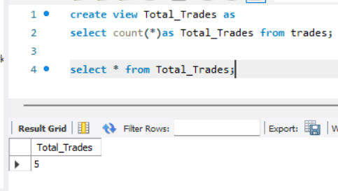
📈 Buy vs Sell Transactions
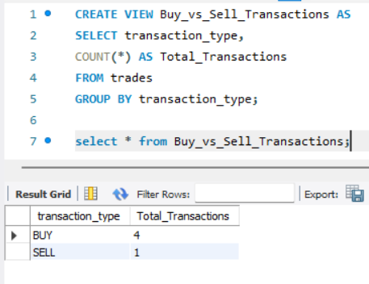
📈 Total Trading Volume
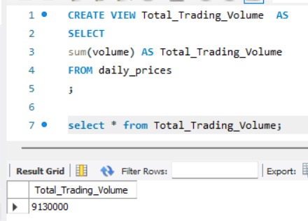
📈 Portfolio Value
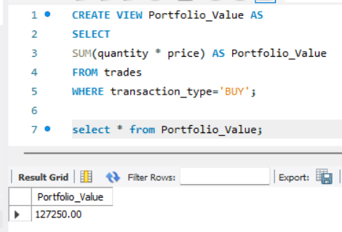
📈 Profit & Loss (P&L)
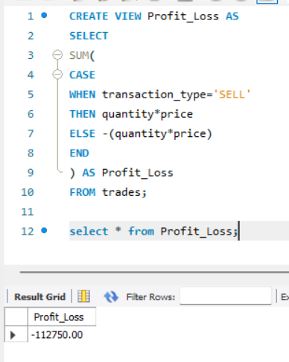
📈 Return on Investment (ROI)
CREATE VIEW ROI AS
SELECT
ROUND(
(
SUM(CASE WHEN transaction_type='SELL'
THEN quantity*price ELSE 0 END)
-
SUM(CASE WHEN transaction_type='BUY'
THEN quantity*price ELSE 0 END)
)
/
SUM(CASE WHEN transaction_type='BUY'
THEN quantity*price ELSE 0 END)
*100,2
) AS ROI_Percentage
FROM trades;

select * from ROI;
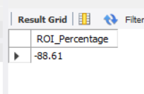
📈 Average Buy Price
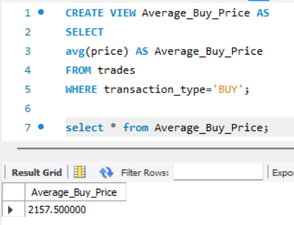
📈 Average Sell Price
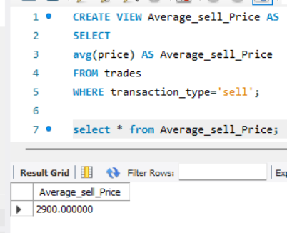
📈 Top Performing Stocks
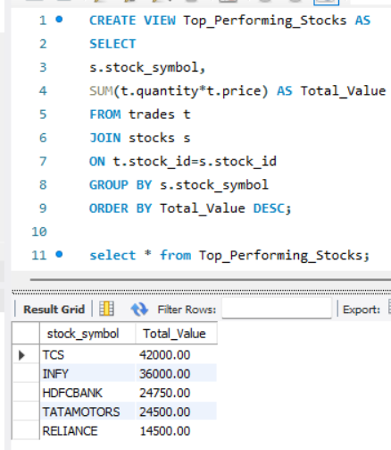
📈 Worst Performing Stocks
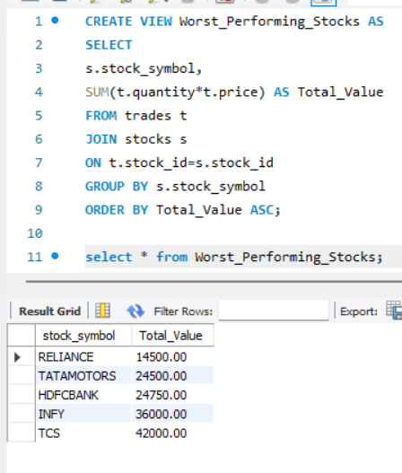
📈 Daily Price Change
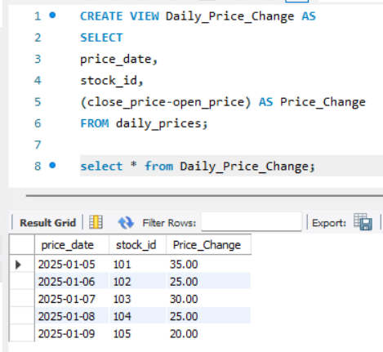
📈 Monthly Trading Volume
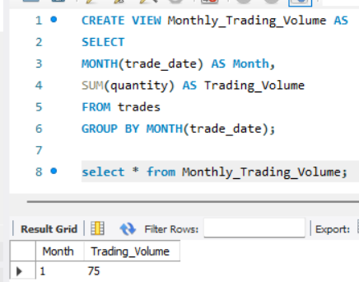
📈 Sector-wise Performance
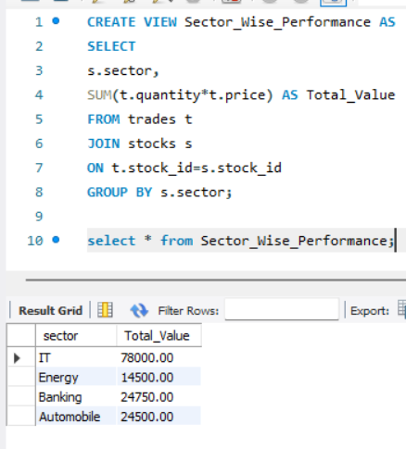
📈 Most Traded Stocks
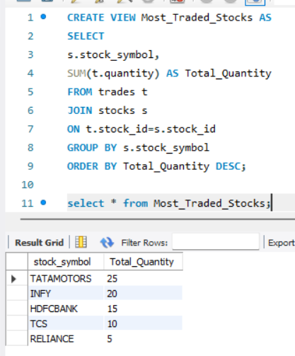
📈 Investor Portfolio Diversification
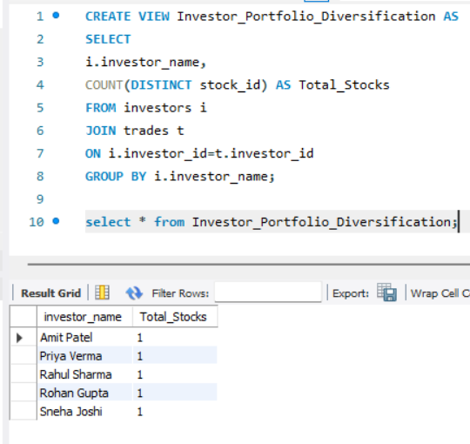
📈 Average Holding Size
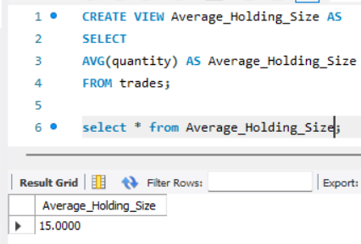
📈 Stock Volatility
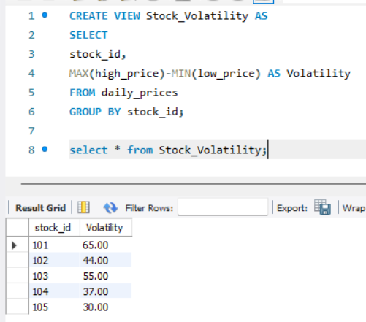
📈 Market Capitalization Trend
